NSDM – Earth Day and Arbor Day
Social Media Messages for Members
Final
Earth Day (Wednesday, April 22)
Post 1:
If your #EarthDay celebration includes planting trees or outdoor projects – big or small, remember to #Call811 to prevent damage to underground utilities and to keep your community safe.
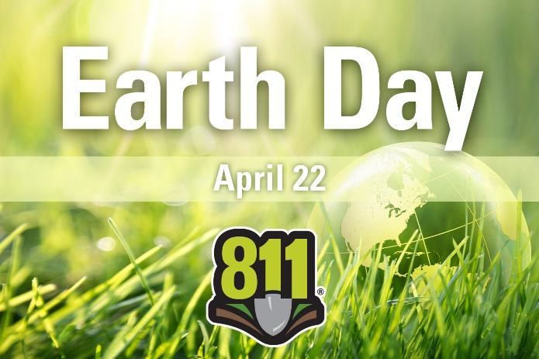
Post 2:
Before you plant trees or greenery this #EarthDay make sure to #Call811 to know what’s below. It’s fast, easy and free!
Arbor Day (Friday, April 24)
Post 1:
It’s important to remember to #Call811 a few days before planting trees this #ArborDay to prevent underground utility damage and connectivity.
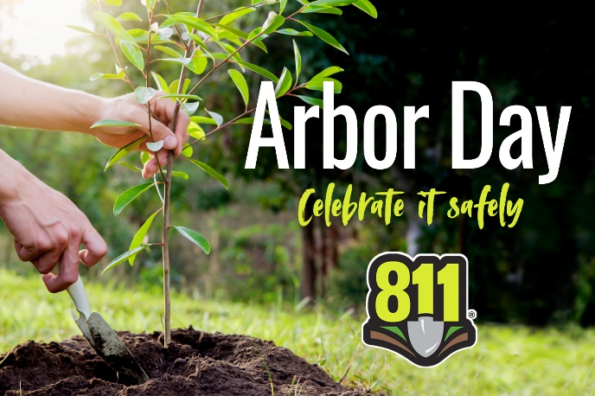
Post 2:
Planting trees this #ArborDay? #Call811 or submit a dig request online a few days prior to digging. Call811.com to learn more

