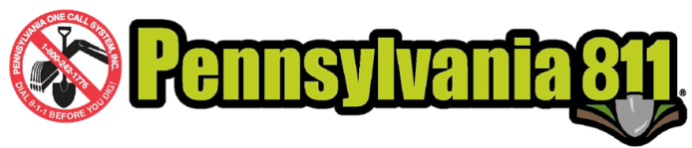
Pennsylvania 811 Recruits Safe Digging Proclamations

from Counties and Local Government Entities

Background
Every year since 1984, Pennsylvania One Call System, Inc. has secured a “Safe Digging” proclamation from the Governor of Pennsylvania, the Pennsylvania Senate and the Pennsylvania House of Representatives. In 2016, the one call center expanded its requests for safe digging proclamations to the 67 county commissioners, and in 2017 further extended its requests for proclamations to the local government level: cities, townships, boroughs and other local government entities.

Execution
Pennsylvania 811 recommends the following steps when developing and executing this safe digging proclamation campaign:

- Develop a contact List. This includes researching an email and telephone number for the county clerk. In Pennsylvania, all county business, including proclamations, goes through the clerk. Initiating the contact via the clerk is more successful and timely than contacting the county commissioner directly. At the local government level, Pennsylvania One Call leveraged its existing member relationship and contacted the representative who handles billing and administrative issues.

- Provide an editable template. The initial contact is via email (county) or telephone call (local government). The body of the email requests a Proclamation to support safe digging. The email also contains at least two different editable examples for the county to choose. The key is to make it as easy as possible for the recipient to create a proclamation.

- Follow Up. Ideally, all requests should be initiated in January, with biweekly follow up via email or telephone. The campaign has a hard stop on March 30. Follow up is key. Pennsylvania One Call initiated contact with email (county) and a phone call (local government), then followed up biweekly with an email or phone call (county and local government.) The local government telephone call is a routine part of the one call center’s business of its liaison team contacting every facility owner every year by telephone. Pennsylvania One Call added the proclamation request as part of the phone call, then followed up with an email upon call completion.

- Keep track and celebrate! When a proclamation is received, it is recorded in a spreadsheet and scanned to a PDF. The spreadsheet is used to create a Google Map (http://bit.ly/PA2017Proclamations) for sharing (on social media, with stakeholders, with reluctant county commissioners, with board members, with CGA and others). The PDF is used as content on social media and in the Google map. Some counties requested a photo opportunity to present the proclamation, which is an additional opportunity to collect high quality social media content.

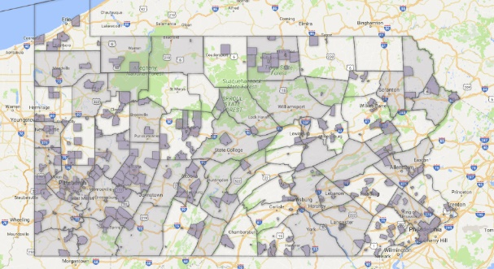
Results
In 2017, Pennsylvania One Call secured Safe Digging proclamations from the PA Governor, the PA Senate, the PA House of Representatives, 40 of 67 county commissioners and 363 proclamations from local government entities: cities, townships, boroughs, and authorities.

For more information about this expanded proclamation campaign, please contact Debi Schwartzmiller at daschwartzmiller@pa1call.org.

EXAMPLE EMAIL TO COUNTY CLERK

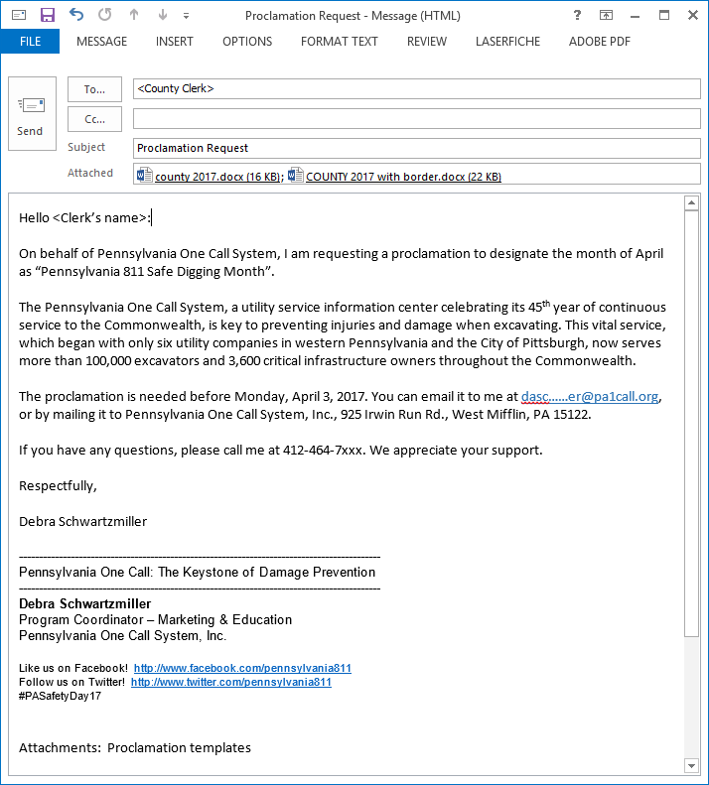
EXAMPLE PROCLAMATION TEMPLATE

