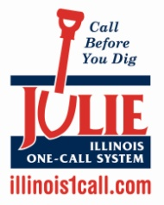
Campaign Overview: JULIE’s Knapsack Program – Where in the World is 811?

Background
As is the case for many damage prevention stakeholders, Illinois’ one call center, JULIE, found it was showcasing a wide variety of promotional and education items to events, only to have a select few picked over and chosen by attendees. In an effort to streamline its educational outreach materials program and get the most important items into the public’s hands, JULIE decided to create one featured item. This item, a draw-string-style knapsack, would capture the public’s interest, while also distributing educational materials that communicate important damage prevention information.

To take things one step further, JULIE challenged recipients of its draw-string-style knapsacks to take photos of themselves with the bags at locations all around the world and email them to JULIE for a chance to earn additional JULIE prizes for their efforts.

Execution
JULIE recommends the following steps to execute a similar campaign in your area:

- Select and purchase a featured item – While knapsacks can be an attractive giveaway item because they can hold a variety of educational materials, consider what the best item will be for your organization. Regardless of the item selected, seek to secure financial support from additional stakeholders since you will be able to offer logo placement in exchange for their financial support. Consider working with a promotional materials broker who can help you obtain the best quality item at the best possible price.

- Coordinate distribution with partners – Take a full inventory of all partner organizations, which can include your fellow damage prevention stakeholder organizations as well as sports teams you may sponsor, retail partners, etc. Work with these partners to find ways to distribute the item to reach the maximum number of people.

- Create a program that incentivizes taking photos of the featured item – While the first year of the JULIE program featured a program that asked people to email pictures of themselves with their knapsacks, JULIE shifted this portion of the campaign to Facebook in 2013 to showcase all submitted photos and build excitement for the campaign. Determine a way to provide a secondary item, such as an 811 T-shirt, to everyone who takes the time to submit a photo, and consider collecting larger prizes, such as gift cards, from your supporting partners. Additionally, consider broadening your promotion to allow for submission of photos of anything having to do with 811 (such as 8:11 on a clock, a mailbox with 811 as the address, etc.).

- Measure Success – There are two ways to evaluate the success of the program – 1) Measuring the number of materials distributed and 2) Measuring the number of entries for prizes. Both of these measurements allow you to determine the amount of engagement with the 811 message that occurred. The key element about this campaign is the depth of engagement that is achieved, especially if someone takes the time to take a photo and submit it to your organization.

Timeline
January-February | Select and purchase featured item and secure sufficient educational materials to include in/with it.
February-March | Coordinate distribution plans with damage prevention stakeholders and other partners. Launch Facebook page in preparation for photo submissions.
April | Begin outreach/distribution to coincide with National Safe Digging Month. Begin collecting photos on Facebook and distributing prizes as needed throughout the spring and summer.
Fall (Exact date depends on how quickly quantity is distributed) | Measure success of the campaign, make adjustments for the following year and distribute grand prizes, if applicable.

Results
In the first year of this program, which didn’t start until the summer due to the number of existing spring programs in 2012, JULIE distributed 3,500 packages across the state. It received photos from places as far away as the Cayman Islands. JULIE was able to more efficiently spend its production budget and increase the public’s level of engagement with the 811 message, and most importantly, call volume was up 7 percent.

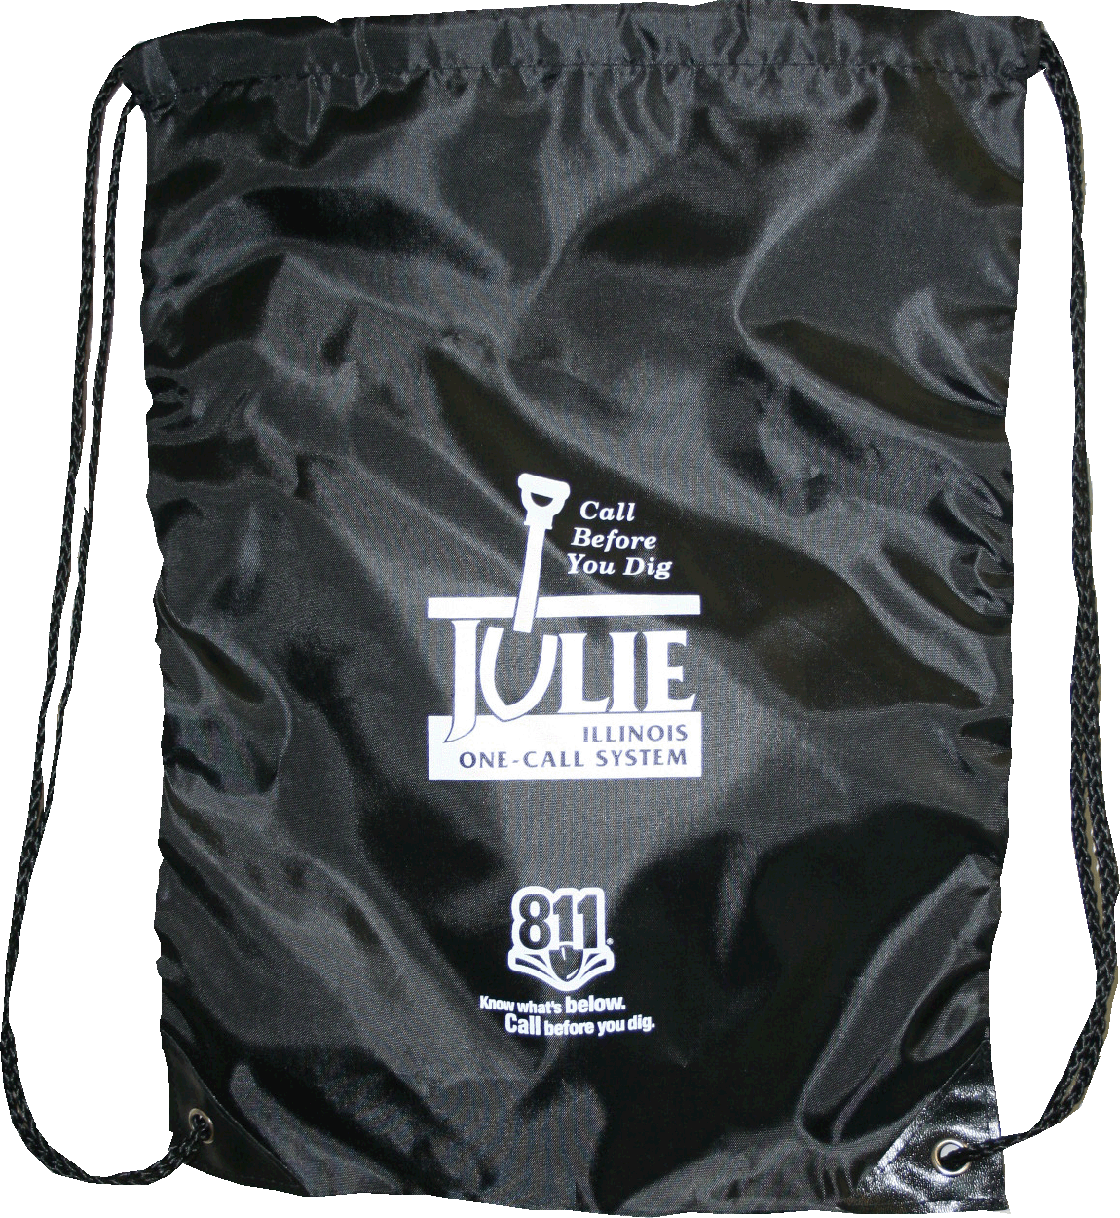
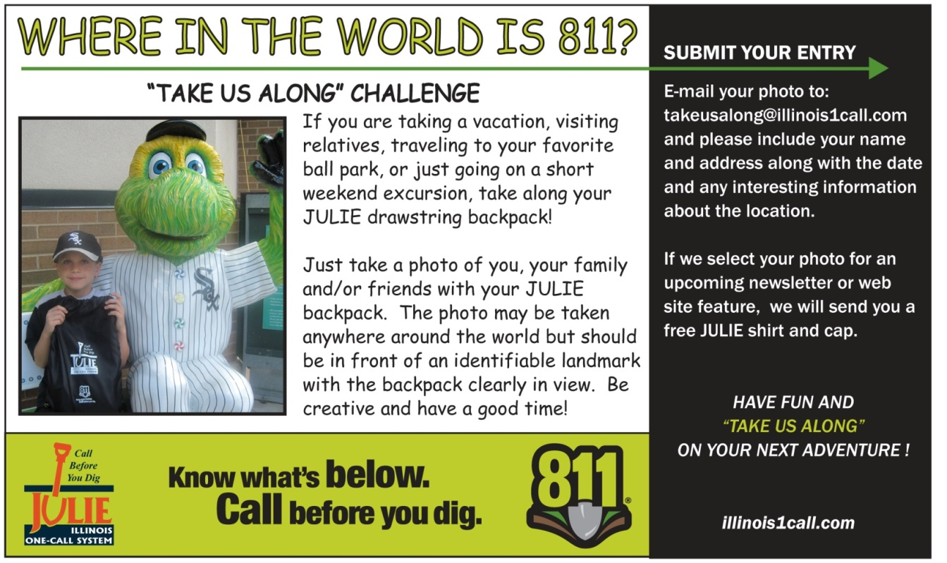
JULIE KNAPSACK PHOTO EXAMPLES

