Southern Star Reaches Key Stakeholders with
National Safe Digging Month Competition for Employees
Background
In 2012, Southern Star Central Gas Pipeline wanted to create a way for its employees to have fun with public awareness activities during National Safe Digging Month. Southern Star developed a contest for its different locations and departments that awarded a prize for the group that best conveyed the safe digging message to stakeholder groups during the month of April. Not only did Southern Star engage many of its employees in National Safe Digging Month, it also reached hundreds of stakeholders through the public awareness activities that were a direct result.
Execution
Southern Star recommends the following steps when developing and executing a National Safe Digging Month competition for employees:
- Set Competition Guidelines – Create guidelines for the contest that encourage employees to develop public awareness activities that target key stakeholder groups and get the best messages across. In Southern Star's competition, employees were asked to target excavators, landscapers, schools, public officials, homeowners or emergency officials with a creative promotion of damage prevention or the call before you dig message. Determine who will judge the entries and develop an evaluation matrix to ensure that all entries will be judged consistently. Southern Star's entries were judged by members of its Public Awareness Team based on originality, message content, concept, outreach and overall success.
- Set Entry Period and Timeline – Give employees the month of April to conduct their public awareness activities. Southern Star employees were given April 1 through April 30 to execute their activities and submit them for consideration in the competition. Have all entries submitted to one email address. Determine when judges will meet to choose the winner, as well as when and how the winner will be revealed. Southern Star's Public Awareness Department reviewed its entries and notified the winning group by the end of May.
- Determine a Prize – Set a budget for the prize. Encourage competition and participation by selecting a reward that will be meaningful to any employee. The winning location or department of Southern Star's competition received a free meal, T-shirts, accolades in the company newsletter and a traveling trophy, which is a chrome shovel with the 811 logo engraved on the blade along with National Safe Digging Month. The wooden handle has a removable chrome plate where the winner is engraved each year, and the winning location or department gets to hold on to the trophy until a new winner is named.
Timeline
Date | Task
January/February | - Determine contest guidelines, judges, entry period, budget, prize, etc.  - Draft email, newsletter article or flier to announce contest to employees
March | - Notify employees of contest
April | - Employees execute and submit their activities for consideration
May | - Select and notify winner  - Announce winner to company  - Evaluate success and reach of contest
Results
Southern Star's National Safe Digging Month competition has prompted many great ideas for stakeholder outreach, including pancake breakfasts for homeowners held at community centers, emergency responder training sessions, and interactive presentations at schools to promote the 811 message and increase awareness of safe digging practices. Southern Star engaged nearly 100 employees with its competition, and the resulting public awareness activities have reached approximately 1,000 stakeholders. For more information about Southern Star's competition, please contact Brad Carter at brad.carter@sscgp.com.
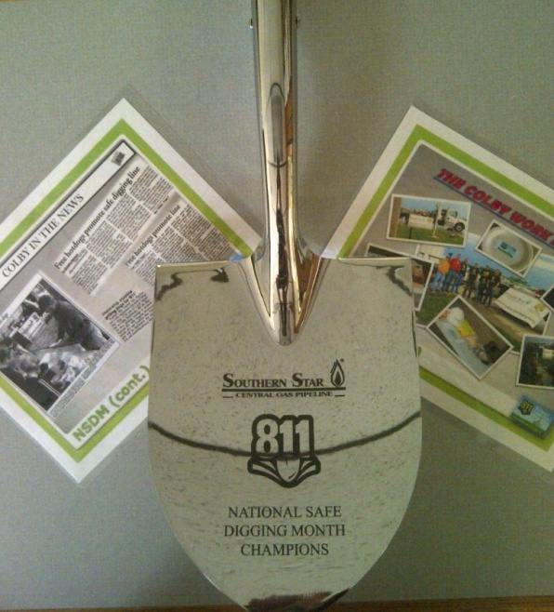
Southern Star's traveling trophy.
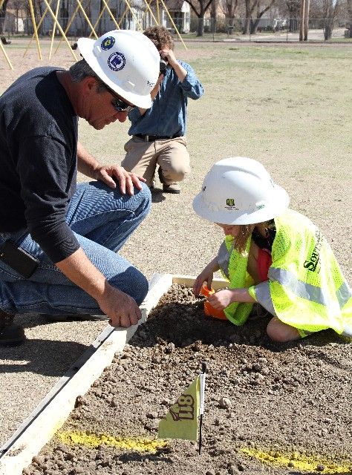
One of the resulting public awareness activities at a local school.

