How-To: Reserve the 811 Bike and 811 Car

The 811 Bike and 811 Car are preparing to hit the road to damage prevention. Paul Teutul, Jr. (Paul Junior Designs) built both these customized motor vehicles and incorporated elements into their design that help educate the public about the importance of using 811 to know what’s below before digging.
More than a million viewers saw the build of the 811 Bike on the Feb. 20 and 27, 2012, episodes of American Chopper: Senior vs. Junior on the Discovery Channel, one of the top-rated shows on cable at the time. Millions more have seen it in person as it has toured the country since its unveiling five years ago.
Hundreds were on hand and thousands more watched on-line when the 811 Car was unveiled at the Greater Chesapeake Damage Prevention Training Conference in Ocean City, Md. on Oct. 19, 2016. Now these two icons will be crisscrossing the country together to help raise awareness about damage prevention.
Tom Hoff, founder, president and CEO of One Call Concepts, Inc. (OCC), commissioned the constructions of these unique vehicles. OCC wanted to create a unique way to convey the message of damage prevention and the sustained popularity of the 811 Bike led to the creation of the 811 Car.
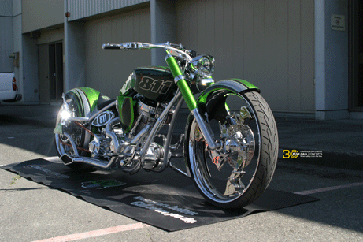
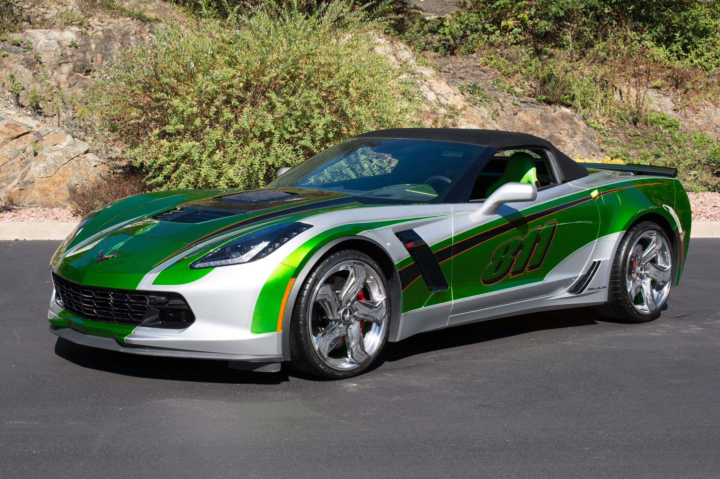

Reserving the 811 Bike and Car
The 811 Bike and Car are available to damage prevention stakeholders for high-attendance public events like state fairs, trade shows, sporting events, industry conferences and conventions.
Hosting a successful appearance by the 811 Bike and Car: A checklist
Adequate covered display space is a key factor in hosting a successful appearance of the 811 Bike and Car. At this time, we are traveling without tents, awnings or other shelter for the vehicles. The 811 Bike and Car must be reloaded into their trailer in the event inclement weather arises during an outdoor appearance.
Crowd size and control are important. In addition to the floor space required to display each of the 811 vehicles, remember that people will gather, look and linger.
Ample nearby parking space for the truck and trailer that house and haul the 811 vehicles are important considerations.
Please note the following and make sure your venue can accommodate:
- A minimum display area of 20ft x 10ft for the 811 Car with adequate surrounding clearance for the passage of the general public.
- Halls, doorways, entrances and exits that are at least 10ft wide to allow the 811 Car to pass.
- A minimum display area of 10ft x 4ft for the 811 Bike, with adequate surrounding clearance for the passage of the general public.
- A nearby parking area at least 15ft x 50ft for the truck and trailer.
- Some type of covering is strongly recommended for outdoor events. In the event of inclement weather, the 811 vehicles will be reloaded into the trailer.
- Consideration should be given to after-hours security. If the vehicles cannot be kept in a locked or secure exhibit area, they must be removed and reloaded at the end of each day. The additional time required for this will reduce the amount of display time that the vehicles will be available.
Requesting the 811 Bike and Car
If your organization is interested in reserving the 811 vehicles for an upcoming event, please send an email describing the event to 811ontheroad@occinc.com. Please include your name and phone number and we’ll contact you regarding availability. Depending on the location and timing of your event, transportation fees may apply.
If your request is accepted, you can expect OCC to:
- Transport both of the 811 vehicles to the event,
- Bike and Car wranglers on site to set-up, monitor, and take down both vehicles,
- Bike and Car wranglers will take questions from the public about the vehicles and are available to answer general questions about damage prevention. We welcome representatives from your organization to join us to answer specific questions about your state or organization.

