NSDM INDUSTRY SOCIAL MEDIA MESSAGES

OVERVIEW
Below are messages that CGA members can deploy during National Safe Digging Month (NSDM) to personally spread safe digging awareness among your networks. Use the suggested posts and accompanying infographics – available to CGA members in the NSDM Toolkit – across your personal LinkedIn, Twitter, Facebook and Nextdoor accounts to reinforce the 811 message to your colleagues, peers and neighbors.

LINKEDIN POSTS

Copy:
Each year, damages to underground #utilities cost the U.S. an estimated $30 billion. April is National Safe Digging Month, marking the start of the busy digging season and acting as a great reminder to #damageprevention professionals that we have a shared responsibility to reduce damages to vital #infrastructure by committing to safe digging practices and raising awareness of #Call811 services. Learn how you can help lower the cost at www.811beforeyoudig.com #811BeforeYouDig

Suggested infographic:

Copy:
#damageprevention pros, do your part in raising awareness about #call811 this National Safe Digging Month! Check out CGA’s active digger research for insight into how to reach this key audience with the safe digging message. For more information and additional NSDM resources, visit www.commongroundalliance.com #NSDM #811BeforeYouDig #CallBeforeYouDig #KnowWhatsBelow

Suggested graphic:
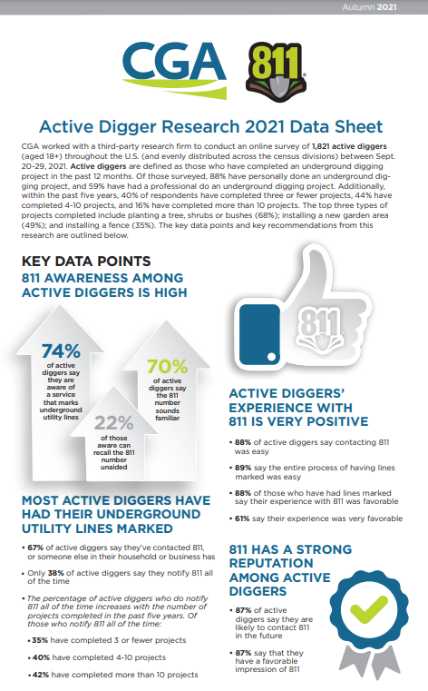

FACEBOOK/TWITTER POSTS

Copy:
Excavators, next time you get in the cab, think: Did you contact 811? Backhoes contribute to more damages to underground #utilities than any other equipment – protect yourself and the buried utilities we rely on by contacting 811 before you dig. Learn more at www.811beforeyoudig.com #Call811 #811BeforeYouDig #NSDM

Suggested infographic:

Copy:
We’re so excited to tune in this Friday for the #Call811 Before You Dig 250 Powered by Call811.com at @MartinsvilleSwy! Join us in cheering for 811 as we help spread the crucial #CallBeforeYouDig message to @NASCAR fans all around the country. #Call811 #811BeforeYouDig #NSDM

Suggested infographic:

NEXTDOOR POST

Copy:
Neighbors, did you know that April is National Safe Digging Month (NSDM)? As the weather gets warmer and we all start spending more time outside, it’s likely that many of us will tackle some DIY projects. Even for small home projects like planting trees or installing a fence, remember to always contact 811 before you dig!

When you contact 811, your local utility companies mark the approximate location of any buried lines in your yard so that you don’t risk injuring yourself or disrupting utility service to the neighborhood. It’s easy to make your free request by calling 811 or going online to [INSERT ONE CALL CENTER URL OR Call811.com]. Every digging project, no matter how large or small, requires a free call to 811. Visit www.811beforeyoudig.com for more info. Happy – and SAFE – digging!

Suggested infographic:

