GENERIC NSDM NEWS RELEASE

[Insert Company Logo]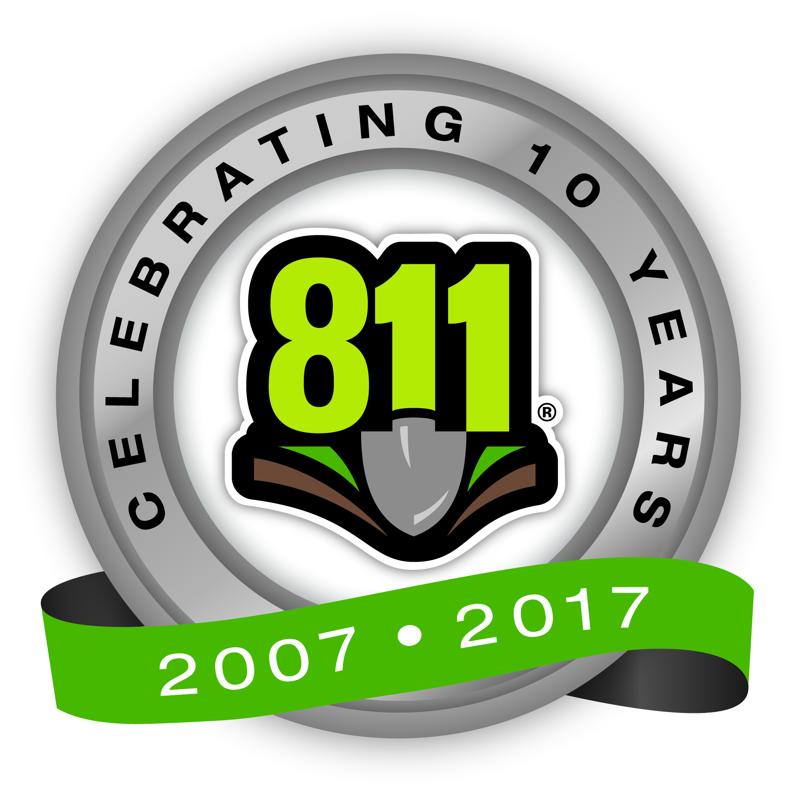
Media Contact:
[NAME]
[PHONE NUMBER]
[EMAIL ADDRESS]

[Insert STAKEHOLDER] Celebrates 10th annual NATIONAL SAFE DIGGING MONTH

[Insert Stakeholder Name] encourages state residents to always call 811 a few days before digging

CITY, STATE, (March 27, 2017) – This April marks the 10th annual National Safe Digging Month, reminding STATE residents to always call 811 [INSERT NOTIFICATION PERIOD] before any digging project. National Safe Digging Month is formally recognized by the U.S. House of Representatives and Senate and has traditionally earned the support from nearly every state governor across the country.

When calling 811, homeowners and contractors are connected to [INSERT STAKEHOLDER NAME], the local one call center, which notifies the appropriate utility companies of their intent to dig. Professional locators are then sent to the requested digging site to mark the approximate locations of underground lines with flags, paint or both. Every six minutes an underground utility line is damaged because someone decided to dig without first calling 811.

Striking a single line can cause injury, repair costs, fines and inconvenient outages. Every digging project, no matter how large or small, warrants a call to 811. Installing a mailbox, building a deck and planting a tree or garden are all examples of digging projects that should only begin a few days after a call to 811.

“As April marks the traditional start of digging season, we are using this month to strongly encourage individuals and companies to call 811 before they begin digging,” said XXX, XXX [Insert stakeholder representative’s name and title]. “By calling 811 to have the underground utility lines in their area marked, homeowners and professionals are making an important decision that can help keep them and their communities safe and connected.”

The depth of utility lines can vary for a number of reasons, such as erosion, previous digging projects and uneven surfaces. Utility lines need to be properly marked because even when digging only a few inches, the risk of striking an underground utility line still exists.
[Insert stakeholder] encourages area residents to visit [Insert stakeholder URL] or www.call811.com for more information about digging safely.

# # #
Contributed Column for nsdm

Make a Call to 811 Part of Your Springtime Plans

Contributed by: [Insert full name, Title of stakeholder executive]

Spring is finally here! With the snow melted and the ground ready for planting, eager homeowners like you are gearing up to start those outdoor digging projects. Before you reach for that shovel to start digging, remember to call 811, the national call-before-you-dig number, to ensure that your buried utility lines are marked.
The Common Ground Alliance and its 1,700 members, including [insert stakeholder], recognize April as National Safe Digging Month. Throughout April, [insert stakeholder] will be promoting National Safe Digging Month through statewide outreach and local events. For more information, visit [Insert stakeholder URL] or www.call811.com.

National Safe Digging Month was designated to remind [Insert state name] residents that our land is made up of a complex underground infrastructure of pipelines, wires and cables. Striking an underground utility line while digging can cause harm to you or those around you, disrupt service to an entire neighborhood, and potentially result in fines and repair costs.
A call must be placed to 811 before every digging project, from simple landscaping projects like planting trees or shrubs, to building a deck or installing a rural mailbox. Every six minutes an underground utility line is damaged because someone decided to dig without first calling 811. Don’t become part of the statistic – make sure to call 811!

Here’s how it works:
- One free, simple phone call to 811 makes it easy for [Local one call center] to notify all appropriate utility companies of your intent to dig.

- Call at least [Insert state notification period] prior to digging to ensure enough time for utility lines to be properly marked.

- When you call 811, a representative from [Local one call center] will ask for the location and description of your digging project.

- [Local one call center] will notify affected utility companies, who will then each send a professional locator to the proposed dig site to mark the approximate location of your lines.

- Once lines have been properly marked, roll up those sleeves and carefully dig around the marked areas.

General nsdm media advisory

[Insert Company Logo]
Media Contact:
[NAME]
[PHONE NUMBER]
[EMAIL ADDRESS]

[Stakeholder Name] to Host

[Name of Event]

Event held in recognition of National Safe Digging Month

WHAT: [Stakeholder Name] will host a(n) [Description of the Event] on [Day], April [Date], 2017 in recognition of National Safe Digging Month. [One to two sentence description of what will be taking place].

This event, held during National Safe Digging Month, highlights the importance of calling [Local one call center number] at 811 to have underground utility lines marked prior to digging.

WHY: Every six minutes an underground utility line is damaged because someone decided to dig without first calling 811. Through this event, [Stakeholder Name] will demonstrate its commitment to improving its community through promoting safe digging practices.

WHEN: [Day of the Week], April [Date], 2017
[Event Starting Time] – [Event Ending Time]

WHERE: [Street Address]
[City], [State] [Zip Code]

For more information visit www.Call811.com or [Stakeholder URL].

# # #

