811 Tank Painting Ceremony on 8/11 Day
Background
Shell Pipeline Company LP wanted to make a big impact for 8/11 Day. And by big, it meant a 100-foot 811 logo on one of its breakout tanks in Pasadena, Texas, a suburb of Houston. Not only did this logo earn daily impressions from the thousands of people who saw it, it also served as the hook for an 8/11 Day event that attracted elected officials and members of the Houston media.

Execution
Shell Pipeline Company LP recommends the following steps to unveil a tank painted with the 811 logo for 8/11 Day:

- Select a Tank and Paint It – Location is key when it comes to creating a 811 logo on a breakout tank. The best possible locations are those that border a major interstate or another busy road or in metropolitan area. Traffic count figures can often be obtained from a state department of transportation to help determine the most strategic location. Marathon Pipe Line LLC, which has also executed an 811 tank painting, also notes that depending on the location of your tank, a permit may be required. Shell estimates the overall cost of painting a tank with an 811 logo can range from $10,000 to $27,000 (excluding lighting costs), depending on the size and internal requirements. Prices may also vary based on the typical cost of specialized labor in your area and whether or not you wish to apply spotlights or permanent lighting to the 811 breakout tank so it can viewed at night Lighting costs may range from $15,000 to $30,000 depending on size and labor expenses.

- Plan Event – Once a location has been selected and arrangements have been made for painting, you can begin to plan your event. The most important element is selecting speakers, from within your organization, national associations such as CGA, and local and state elected officials. Once speakers are confirmed, develop a schedule (sample schedule is included in this section). The best time for an event for media and guests is typically the late morning hours.

- Invite Guests – Invite guests either by mail or html email at least 3-4 weeks in advance of the event. Manage RSVPs and plan set up and refreshments accordingly.

- Conduct Media Outreach – Complete attached media advisory template and distribute to local media at least three days before the event. Conduct phone follow up the day before and morning of the event. Offer 811 fact sheet to media who attend the event.

Timeline
Date | Task
April | Select tank location and solicit bids for painting
May | Contact elected officials and other potential speakers
June | Develop event agenda
July | Invite additional guests
August | Paint tank  Conduct media outreach  Host ceremony  Collect media coverage results (also available through CGA)

Results
Shell Pipeline had secured the attendance of two state representatives, as well as reporters from several major suburban newspapers in the Houston area, raising the profile of the event and ensuring its message reached beyond those in attendance and those who regularly pass the tank. For more information about this campaign, please contact Gweneyette Broussard at c.broussard@shell.com.

Resources
Marathon Pipe Line LLC and Vectren have also executed 811 tank paintings, using Native Sun (Valparaiso, Ind.) and Eric Henn as the painting vendors, respectively. Please contact Tracey Bryant with Vectren (TJBryant@vectren.com) or Craig Potts (capotts@marathonpetroleum.com) with Marathon for additional information.

SAMPLE TANK DEDICATION CEREMONY AGENDA

11:30 a.m. Check-in
Responsibility: {logistics contact}

Notes:
- A check-in table will be set-up inside the conference room where nametags will be provided to guests
- A sign-in sheet will be at the check-in table to distribute follow-up materials
- 811 Fact Sheet will be distributed
- Media Release will be available for press

11:45 a.m. Welcome
Responsibility: {senior executive}

Notes:
- Welcome guests and recognize public officials
- Explain the schedule of events
- Introduce guest speakers

11:50 a.m. Safety Speech, {senior executive}

12 Noon Invite Guests to have Lunch

12:45 p.m. Storage Tank Dedication - {CEO, President or Equivalent}
Note: Commemorative plaque presentation

12:55 p.m. Photo Opportunity

1:05 p.m. {CEO, President or Equivalent} to Introduce State Representatives
(Invite them to say a few words)

1:06 p.m. State Representative
Photo Opportunity

1:10 p.m. State Representative
Photo Opportunity

1:15 p.m. Goodie bag distribution
Responsibility: {tbd}

Note:
- Pick-up giveaways at check-in table
- Goodie bag to contain 811 and member company logo items as well as 811 brochure

TANK DEDICATION MEDIA ADVISORY

[Insert Company Logo] 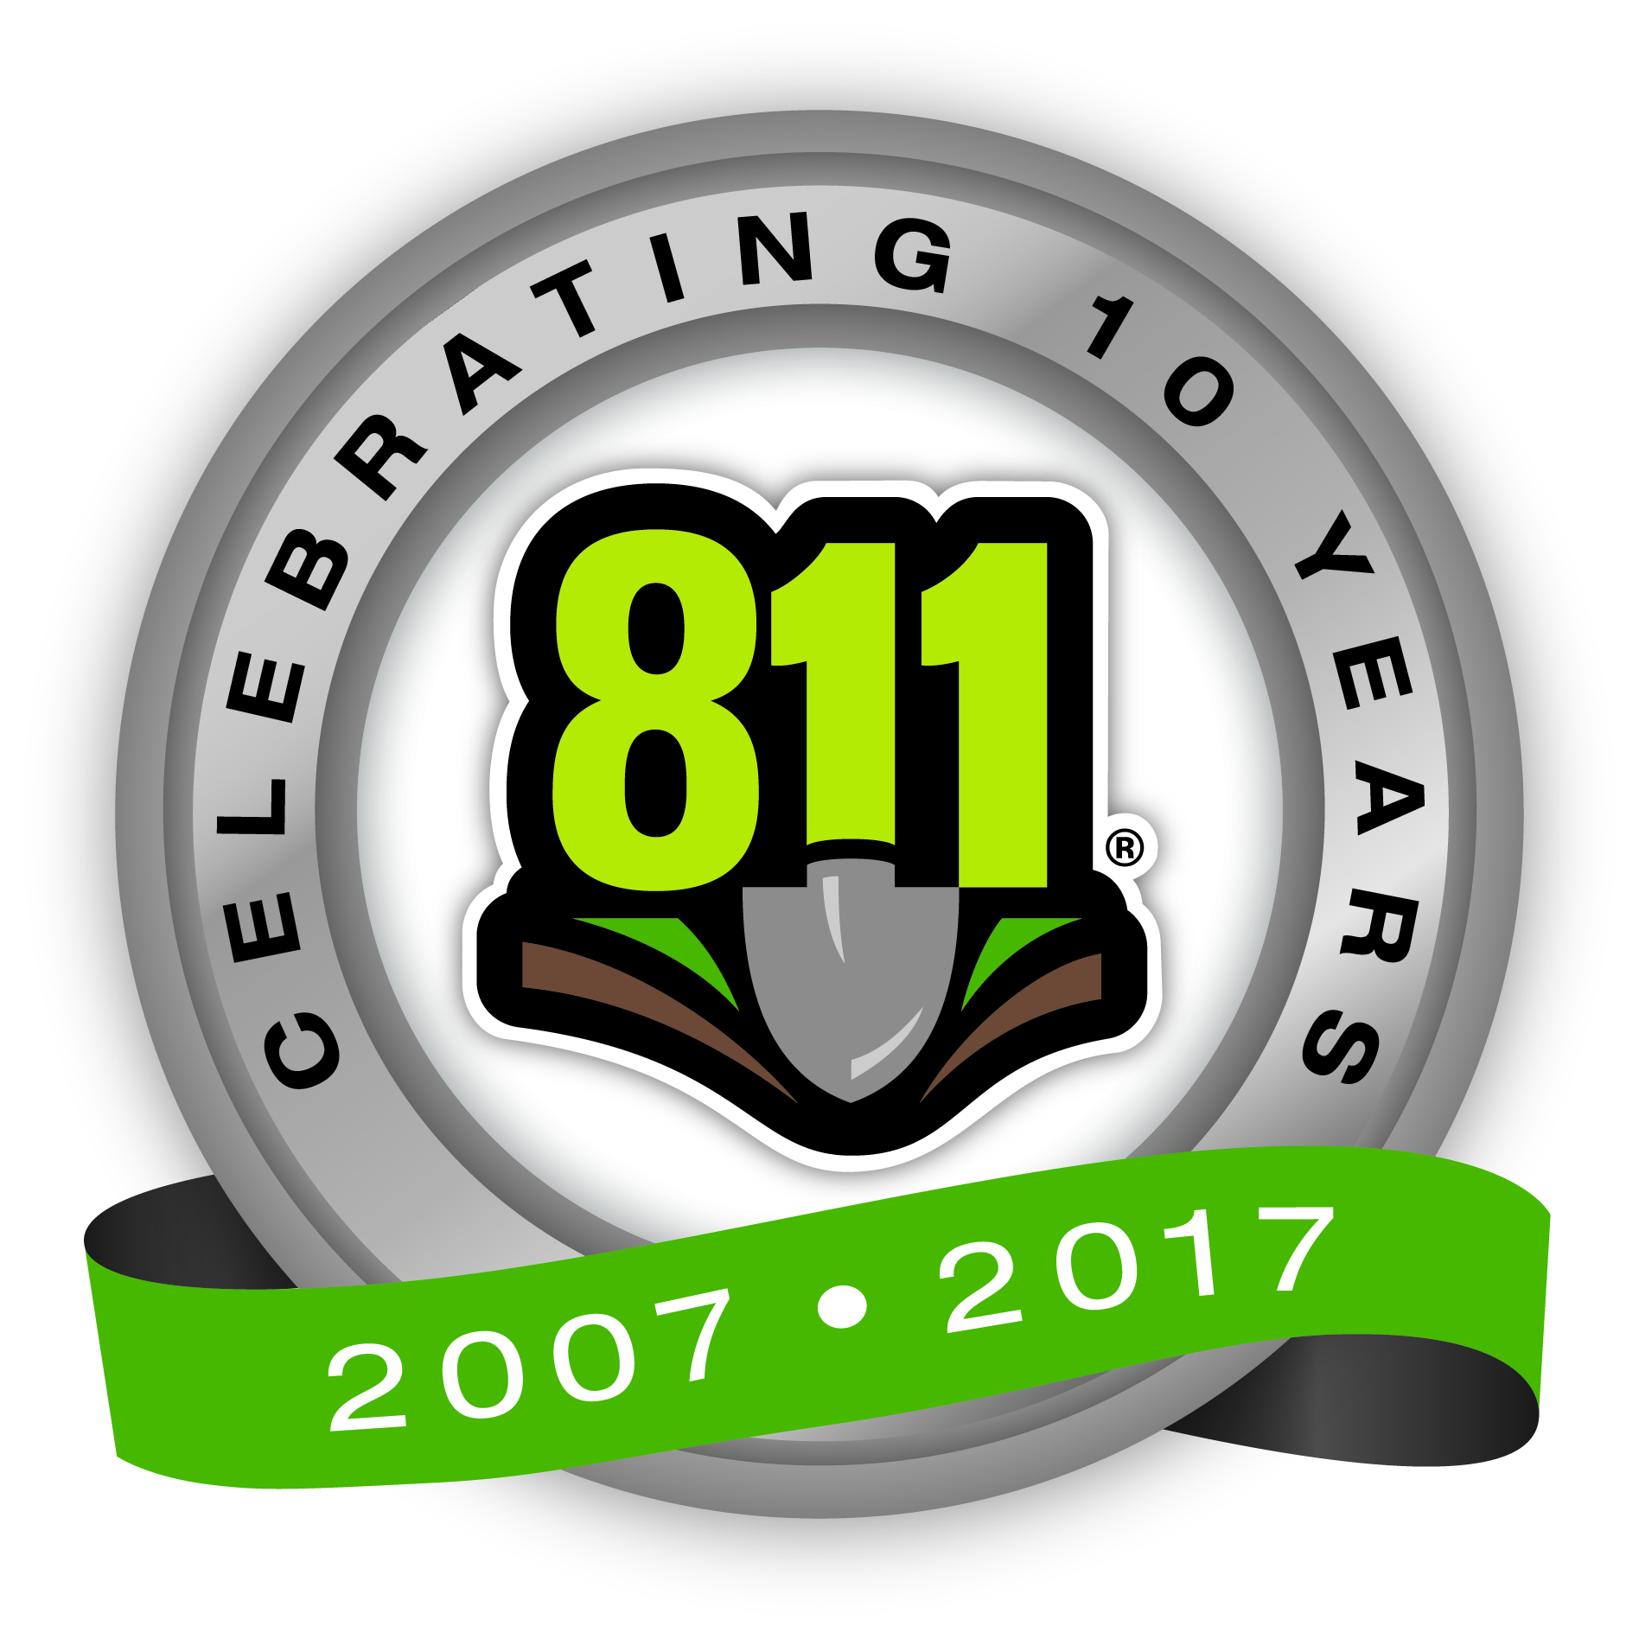
Media Contact:
[NAME]
[PHONE NUMBER]
[EMAIL ADDRESS]

[Stakeholder Name] and Elected Officials to Celebrate Aug. 11 (8/11) by Dedicating Storage Tank Featuring Giant ‘Call 811’ Logo

WHAT: Representatives from [stakeholder name] will join [elected officials’ names] to dedicate a storage tank in [location] that now features a [size] logo of the 811 call-before-you-dig telephone number. [Stakeholder name] is a member of the Common Ground Alliance, the national association that promotes the 811 phone number and safe digging practices.

WHY: Every six minutes an underground utility line is damaged because someone decided to dig without first calling 811 to learn the approximate location of underground lines in their area.

This event is designed to raise awareness among [state] residents of the importance of calling 811 to avoid damage to underground utilities, which can potentially cause injuries and inconvenient service outages.

Aug. 11 is “8/11 Day,” due to the date having a natural connection to the 811 phone number.

WHEN: Aug. 11, 2017
[Insert Event Starting Time] – [Insert Event Ending Time, if applicable]

WHERE: [Insert Street Address]
[Insert City], [Insert State] [Insert Zip Code]

For more information visit www.Call811.com or [Stakeholder URL].

# # #
TANK DEDICATION Internal communications template

A Large Reminder to Call 811

Today is August 11 (8/11 on the calendar), which serves as a good reminder to everyone to call 811 a few days before digging to identify the approximate location of underground utility lines.

Every six minutes an underground utility line is damaged because someone decided to dig without first calling 811, and we at [Insert Stakeholder Name] do not want anyone to become part of the statistic.

Utility services that your family depends on, such as cable TV, high-speed Internet, landline telephone, electric, gas, water and sewer, are buried underground in many communities. Striking one of these lines can result in inconvenient outages for entire neighborhoods, harm to yourself or someone else, and repair costs.

For this reason, [Insert Stakeholder Name] has decided to make a major investment in spreading this important message, in the form of a [dimensions] 811 logo on a storage tank in [location].

This tank will be officially unveiled at an event later this morning, where [company official name] will speak about our company’s commitment to damage prevention. [Elected officials names] and [association representatives] will also be in attendance at the event to speak about the importance of promoting safety.

When you call 811 a few days before you plan to start your project, a local one-call center representative will collect your information and notify the affected local utility companies of your intent to dig. A professional locator will then visit the dig site to mark the approximate location of all underground utility lines with paint, flags or both. Once your site has been marked, it is safe to begin digging around the marked areas.

No matter the type of project – installing a mailbox, putting in a fence, planting trees or shrubbery, building a patio or deck, or excavating a new garden area – make sure to call 811 several days prior to digging to have your site properly marked, and remind our customers, as well as your friends and family, to do the same. Always call 811 before you dig and know what’s below.

[Email signature if applicable]

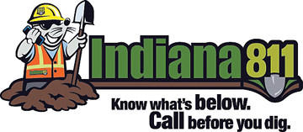
8/11 Day Campaign – Cake Delivery

Background
Indiana 811 was looking for a fresh way to get the media’s interest on Aug. 11 for the annual CGA 8/11 Day campaign. Less than four months had passed since National Safe Digging Month (NSDM), which is the one time each year that Indiana 811 makes a major push to secure interviews about the importance of 811. Since 811 is a constant message, the goal was to communicate it in a new way that would get the media’s attention.

The solution was targeting radio stations, which have hours of content to fill in the morning, and delivering 8/11 Day cakes, along with 811 information, to get their attention and spread the word. The idea for cakes came from knowing how early morning radio people wake up and how eager they are to get some food during their shifts. Also, the cakes can showcase utility markings and the 811 logo.

Execution
Indiana 811 recommends the following steps to make a cake delivery campaign a success.

- Make a Preliminary Media List – Consider which stations are the best fit to receive 811 cakes. Radio stations in general are the best fit; especially ones that originate from your market (aren’t syndicated from somewhere else). Good targets allow for host interaction and not just a regimented schedule of music or news/traffic/weather. In addition to radio stations, consider dropping off cakes to TV stations that may have covered 811 during NSDM.

- Contact Media Outlets and Finalize Media List – While it seems like getting surprised with a cake would be a good thing, in reality it’s better to pitch the media in advance. The best time of the day to contact morning show producers is immediately after the show goes off the air, via the main phone number for the station. Just explain who your organization is, why 811 is important and that you’d like to drop off a cake during the morning show on Aug. 11. Take note of any special instructions for parking or building entry and finalize your list based on the stations that would like to receive a cake.

- Order Cake or Cupcakes – Contact grocery stores or Wal-Mart in your area to see what their cost is for customized cakes or cupcakes using jpeg images like the ones contained in this folder. Make arrangements for you and/or your volunteers to pick up the cakes on the afternoon of Aug. 10, before the bakery closes.

- Prep and Make Your Deliveries – Attach basic information about 811 and how it works to the cake/cupcake boxes. Make your deliveries on the morning on Aug. 11 and be prepared in case you’re asked to talk on air.

- Save Some For the Office – Consider having 811 cakes at the office to reinforce the 811 message to employees.

Timeline
Date | Task
8/1 | Make preliminary media list
8/2 | Contact stations to confirm interest in receiving cakes and 811 information
8/8 | Place orders for cakes
8/10 | Pick up cakes and plan your deliveries
8/11 | Deliver cakes – early morning

Results
A couple of weeks after a delivery, Indiana 811’s Chuck Muller attended a community event, where he met one of the on-air personalities that received a cake. That radio host remembered the cake and 811, a testament to the unique nature of the program. Indiana 811 worked with stakeholders across the state to secure several in-studio interviews. It’s important to note that this program is not meant to be a hard sell of 811 to media outlets. Instead, it’s meant to be a friendly reminder, through which the cake and the fact sheet do the talking and possibly lead to 811 being mentioned on the air.
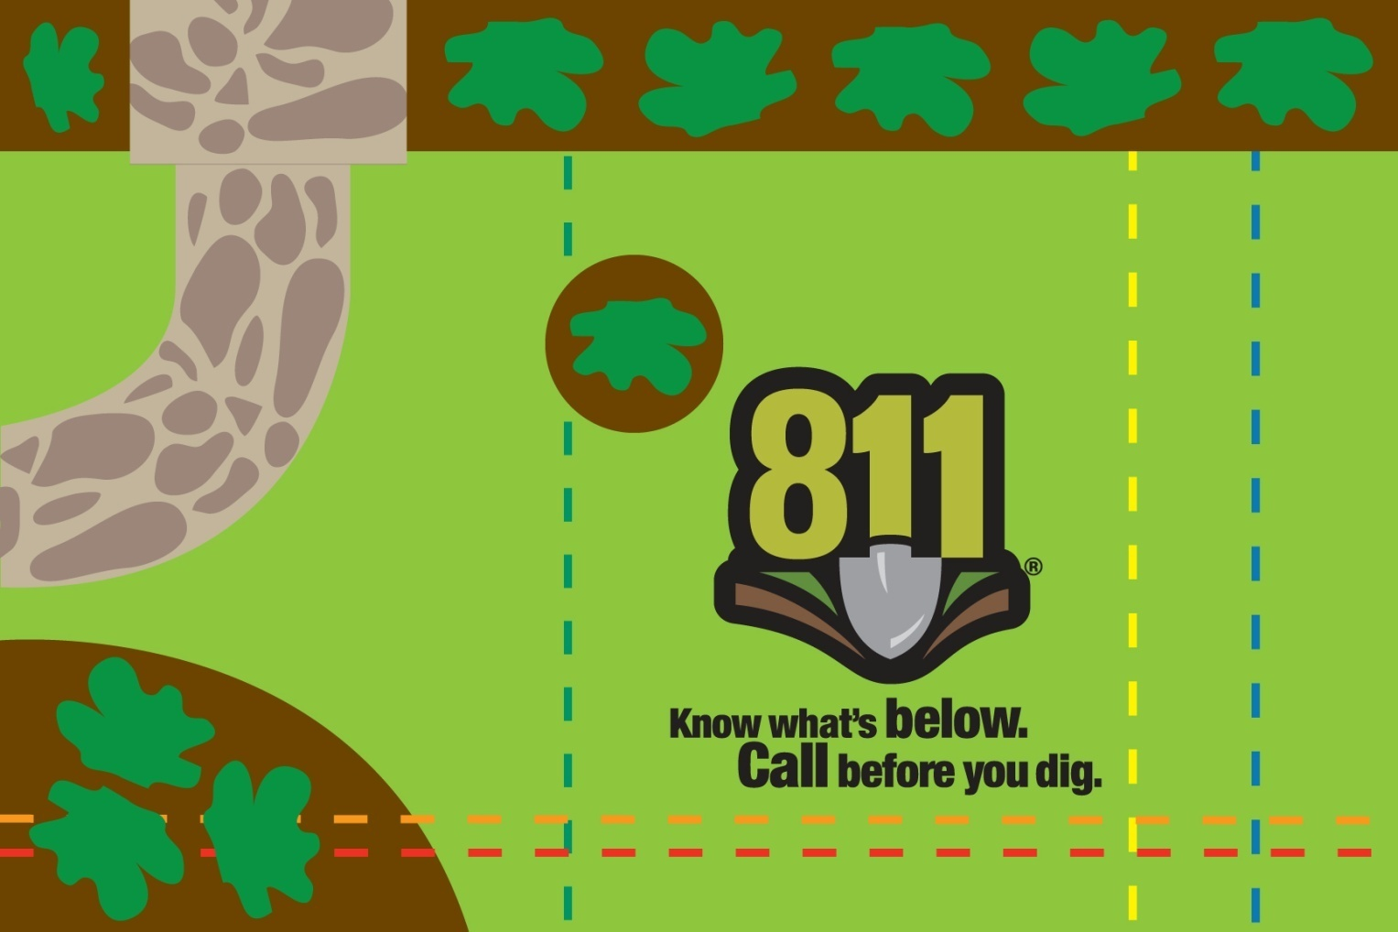
CAKE ARTWORK

Campaign Overview: Miss Utility’s 8/11 Day Free Coffee Program

Background
Convenience stores are a common stopping point for many morning commuters, but especially so for contractors, who are often grabbing food on the go and picking up ice and water for hot summer days. Given this demographic trend, Miss Utility of Maryland/D.C. and Miss Utility of Delmarva – the one call notification centers for the region – sought to develop a partnership that would promote the 811 phone number in partnership with a large chain of convenience stores.
Execution
Convenience stores aren’t natural partners of the damage prevention industry, so the two Miss Utility groups asked their marketing agency, MGH, to develop a partnership proposal that might interest Royal Farms, a 200-unit convenience store chain in the mid-Atlantic that is very popular with workers in the damage prevention stakeholder industries. Here’s how the Miss Utility groups were able to partner with Royal Farms to offer a free cup of coffee on 8/11 Day (Aug. 11).
- Finding the right person – The outreach approach was rather simple – MGH called Royal Farms’ corporate phone number, asked to be connected to someone in marketing and left a message.
- How’d Miss Utility get a call back? – The top asset that Miss Utility could offer to Royal Farms was access to the extensive database of contractor and facility operator email addresses, so the free coffee would be offered exclusively to people who already receive email updates from Miss Utility. This fact was the primary message of the voicemail left by MGH.
- How would it work? – Once Royal Farms was on board, Miss Utility proposed that it would send a Miss Utility/Royal Farms co-branded email the day before 8/11 to every contact in its combined database, thanking the recipients for being partners in damage prevention and offering them an exclusive coupon for a free cup of coffee at Royal Farms on 8/11 with any purchase. The marketing and operations teams at Royal Farms had to work to activate this coupon and make it work in their system, but that was a minor delay in the planning process.
- Creating and sending the email – Royal Farms took the lead on email design, using text provided by Miss Utility. Miss Utility managed the creation of the HTML email and sent the email using its email distribution service.
Timeline
To achieve an 8/11 Day promotion, the following dates can serve as a good guideline:
- April – Make list of top potential partners and try to establish contact.
- May – Establish offer rules and key messages for all parties.
- June – Draft and design email.
- July – Finalize all plans.
- August – Send email.

Results
More than 4,000 opened the email about the offer and 250 coupons were redeemed at Royal Farms locations. Miss Utility and Royal Farms plan to promote this a bit more in advance in 2016 to hopefully increase coupon redemption. For more information about this campaign, contact Dora Parks at dparks@missutility.net or Chris McMurry at cmcmurry@mghus.com.

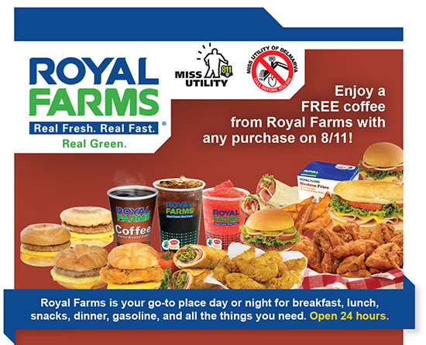

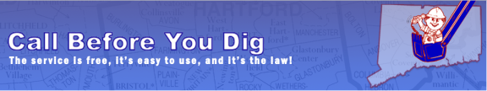
Call Before You Dig Connecticut and Stafford Motor Speedway Partner to Create 811 Challenge

Background
As 2012 came to a close, Call Before You Dig (CBYD) Connecticut proposed a unique and engaging way of promoting 811 awareness during the 2013 digging season as part of its sponsorship at Stafford Motor Speedway: the Call Before You Dig 811 Challenge, in which drivers from five NASCAR Whelen All-American Series divisions competed in weekly races from April through mid-August, accruing points towards the CBYD 811 Challenge. On Aug. 16, just after 8/11 Day 2013, CBYD Connecticut hosted a Call Before You Dig event at the speedway, and this date served as the culmination of the contest, or the last day that drivers could earn points. The five drivers whose total points were closest to 811 each received $811 each from CBYD Connecticut at an Aug. 23 awards ceremony. Through this promotion, CBYD Connecticut was able to reach thousands of stakeholders with safe digging messages.

Execution
CBYD Connecticut recommends the following steps to plan a speedway challenge:

- Identify potential partners – This is a great opportunity to leverage an existing partnership with a speedway or create a new one. Work with the speedway to plan a challenge or event to spread 811 and call before you dig messages. It would be best to reach out at least six months from the tentative event date to start coordinating.

- Plan Event – Once you have a contract with the local speedway, you can start planning your event. Discuss dates, the rules of the challenge, event details, promotions, timeline and activities.

- Invite Guests – Invite local utility companies, contractors and other key stakeholders to attend and participate in the event. It is a great opportunity for organizations to come together to help promote 811. Give tickets away as door prizes. CBYD Connecticut members distributed tickets to utility companies and associations and gave them away as door prizes at industry-related events.

- Promote Event – Create visuals such as banners or promotional videos that can be used to promote the event at the track (if your partnership allows), as well as on social media sites like Facebook, LinkedIn and Twitter. Design and distribute T-shirts to promote 811 awareness during the challenge.

- Conduct Media Outreach – Complete the press release template and distribute to local media and race industry publications at least three days before the challenge begins. Conduct phone follow up the day before and morning of the event. Offer 811 fact sheets to media who attend the event.
Timeline
Date | Task
January | - Reach out to local speedway to conceptualize the challenge
February | - Draft and distribute press release announcing Call Before You Dig 811  Challenge  - Design T-shirts
March to April | - Promote the challenge, invite guests, order T-shirts and develop video promotions
April | - Challenge begins
May to August | - Promote the challenge and continue to invite guests
August | - Post race results online after challenge ends  - Host awards ceremony  - Measure results

Results
Through the challenge, CBYD aired three 30 second spots on the speedway’s TV system and races were televised on Connecticut Public Television (CPTV) Sports channel. CBYD displayed signage on the speedway and distributed literature regarding safe digging practices to the 3,000 to 4,500 fans who attended the races each week. The SMS Fast Times Newsletter, an online newsletter that is emailed to more than 2,000 members weekly, covered the challenge as well as Area Auto Racing News, Hartford Courant, Journal Inquirer, Newtown Bee, Norwich Bulletin, RaceDayCT.com and YankeeRacer.com. For more information on this campaign, please contact Derek Brown at Derek.Brown@ct.gov.

NEWS RELEASE ANNOUNCING CALL BEFORE YOU DIG 811 CHALLENGE

[Insert Company Logo]
Media Contact:
[NAME]
[PHONE NUMBER]
[EMAIL ADDRESS]
ONTINGENCY SPONSOR
[STAKEHOLDER] TO HOST CALL BEFORE YOU DIG 811 CHALLENGE AT [NAME OF SPEEDWAY]
[CITY, STATE] (Feb. [date], 2017) — [Name of Stakeholder] today announced it will host the Call Before You Dig 811 Challenge at [Name of Speedway] during the 2017 season as an opportunity to educate [State] residents to call 811 before any digging project to prevent injuries, property damage and inconvenient outages. During the challenge, drivers from [Racing series or divisions] will compete in weekly races from [Month] to [Month] and will conclude at the Call Before You Dig Event on [Date]. The drivers whose total points come closest to 811 will each receive $811 from [Name of Stakeholder].

“We are thrilled to sponsor the Call Before You Dig 811 Challenge with [Name of Speedway] to highlight the importance for homeowners and contractors to always call 811 prior to starting any digging project large or small,” said XXX, XXX [Insert stakeholder representative’s name and title]. "We're always looking for fresh ideas to promote the importance of calling 811 and this challenge will spread our message to thousands of [State] residents in an exciting atmosphere at [Name of Speedway]."

An underground utility line is damaged every six minutes because someone decided to dig without first calling 811 to learn the approximate location of underground lines, according to data collected by the Common Ground Alliance (CGA), the national organization dedicated to protecting underground utility lines and the people who dig near them. This event is designed to raise awareness among [State] residents, professional excavators, contractors and utility workers of the importance of calling 811 to avoid damage to underground utilities, which can potentially cause injuries and repair costs.

For more information on safe digging, please visit call811.com.

[Boilerplate]

###

cBYD conneticut DISPLAY sign on the speedway

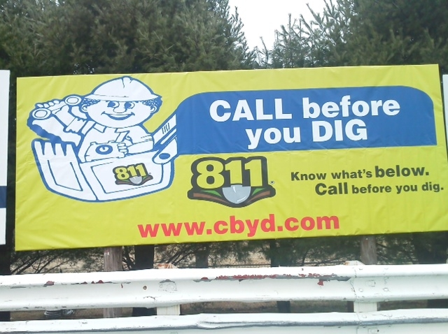

Cover the Skies with 811 on 8/11

Overview
With the challenges of 8/11 falling on a weekend day in 2012, Miss Utility of Maryland and D.C. and Miss Utility of Delmarva were searching for a new way to spread the safe digging message to large numbers of people. Given the organizations’ proximity to several miles of popular beach destinations on the east coast, they came up with the idea of contracting with an airplane advertising company to fly over several beaches on the Maryland and Delaware coasts with safe digging messages on 8/11 Day. On 8/11 Day, a plane featuring the 811 message flew over packed regional beaches five times.

Other damage prevention stakeholders can execute similar plane flyovers the weekend before 8/11 Day this year to be featured at their regional beaches, state fairs or other large outdoor gatherings. Planning for the plane flyover messages is as simple as reaching out to an aerial advertising company in your area, determining an advertising plan for 8/11 Day that suits your organization’s budget and selecting a safe digging message to display.

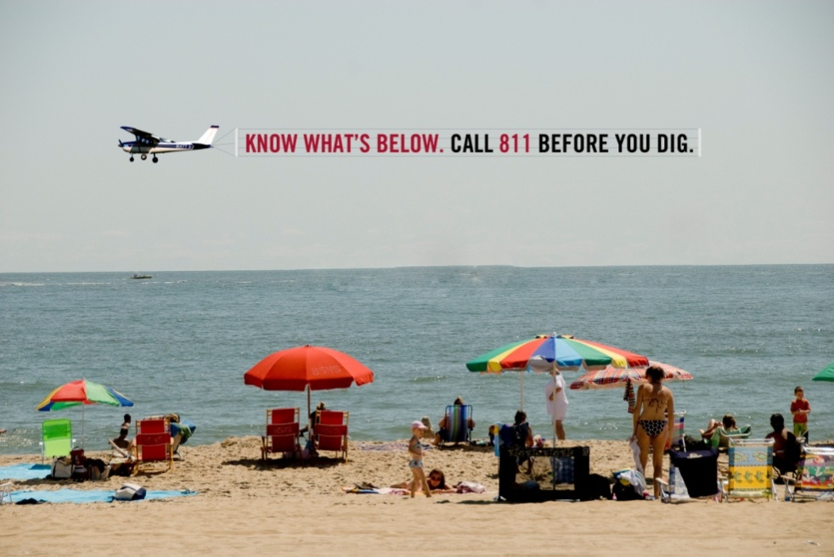

Sample safe digging messages
Because of the aerial nature of this campaign, it is recommended that organizations choose a concise but impactful message. Here are a few sample messages (actual messages used will depend on space provided by your local aerial advertising company):
- Know what’s below. Call 811 before you dig.
- Happy 8/11! Always call 811 before you dig.
- Digging soon? Stay safe by calling 811 first.

811 Night at the Ballpark on 8/11 – A Night for Stakeholders

Overview
In past years, some stakeholders have worked with minor league baseball teams to create $8.11 ticket opportunities that help promote the 811 phone number. In 2011, Vectren and Indiana 811 partnered to offer free tickets for the Aug. 11 game in Evansville, Ind., to the first 250 targeted stakeholders who claimed them. Indiana 811 and Vectren worked together to target stakeholders within a one-hour drive of downtown Evansville via email, directing them to a page created at EventBrite.com that allowed everyone invited to reserve up to four complimentary tickets for the game, courtesy of Vectren and Indiana 811.

At the game, Vectren and Indiana 811 took advantage of their combined presence in the stadium in the form of an in-game contest, billboard and restroom advertising to make sure all recipients who attended the event were fully reminded that calling 811 before digging is always a good decision.

Action Items
If your organization would like to invite stakeholders to a game as a way to promote the 811 message, the following would be good steps to take:

- Confirm your local team has a home game on Aug. 11. If it does not consider a date close to Aug. 11 on the calendar.
- Contact a group sales representative at the selected team to enquire about the discounts for large groups. Also, ask if your organization can be welcomed by name with the 811 logo on the video board (if available) the night of the game.
- After purchasing the tickets, create an email list of qualified targets.
- Create an event page at EventBrite.com as a way to manage ticket requests with ease.
- Send an email about the promotion to this list, emphasizing any restrictions (maximum number of tickets per person, etc.) directing them to request tickets at EventBrite.com page.
- Collect names of ticket recipients and give them to the baseball team to leave at will call.
- Send email blast with any necessary instructions to ticket recipients in advance of the game night.
- Work with baseball team representatives to ensure 811 exposure at the game that night.
- Enjoy the game and enjoy spreading the 811 message to a targeted group of stakeholders!

Measuring Success
The following metrics can be used to determine success for this campaign:
- Number of tickets requested.
- Number of tickets redeemed.
- Breakdown of stakeholder type for tickets requested and redeemed.
- Amount of in-stadium 811 exposure earned for bringing a large group to the stadium.

Best of luck, and play ball!

Putting the 811 Message in Lights – An 8/11 Day Promotional Opportunity
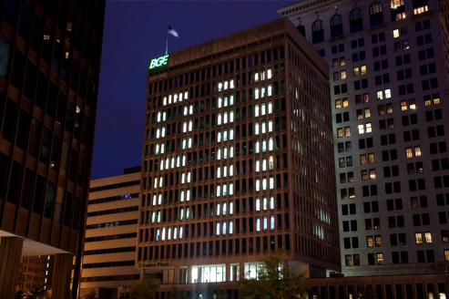
Overview
Explaining underground utility damage prevention to the general public in a visual way can be difficult. As a result, one potential 811 promotional idea would be to make the message easy-to-understand and visual by having stakeholders in your city light up buildings with a vertical “811” by strategically turning on select office lights around 8:11 p.m. local time. (Check weather reports to find out the expected time of sunset in your area). In 2012, Baltimore Gas and Electric executed this eye-catching campaign to great effect.
This could be executed with events, media relations and social media used to increase impressions beyond just those who are near the building(s). If several buildings in the same area are all able to accomplish this feat, it will make the campaign much more effective.
How it Would Work
- Participating stakeholders would make arrangements as soon as possible with their respective facilities management teams to determine which office lights would need to be illuminated and which would need to be turned off to create the appearance of a vertical 811 on all sides of their office buildings.
- Ideally, the stakeholders would test the lighting process during overnight hours on a date prior to Aug. 11 so as not to attract much attention to the test.
- Once the lighting logistics are determined, the next steps would include creating an event to unveil the lighting display to elected officials, general public and media. A Sunday evening event near the building(s) could include:
  - Activities for families (attendees would primarily be stakeholder employees)
  - Music
  - Light refreshments (ice cream could be a good fit that time of the year)
  - Stage and podium for a formal presentation
  - 811 signage
- Invite media to attend the event using an event media advisory template this 2017 Communications Plan. Invite dignitaries through their representatives. Make plans to document on social media platforms.
- The formal presentation would include the following elements as dusk sets in and the lights left on in each building illuminate several 811’s across the skyline:
  - Official welcome by stakeholder(s)
  - Introduction of elected official(s)
  - Explanation of why 811 matters and what is about to happen – provides sound bites for media
  - Photo/video opportunities as dusk turns to darkness
  - Celebration continues for 30 minutes after the short ceremony ends
  - Individual media needs can be accommodated immediately after the formal presentation
- The campaign would be measured based on the number event attendee, amount of media coverage and social media engagement.
For More Information
For more information about how to orchestrate an 811 in Lights campaign, contact Aaron Koos at aaron.koos@bge.com.
Spread the 811 Message at Community Events Prior to 8/11

This year Aug. 11 (8/11 on the calendar) falls just before a weekend, providing the option to share the 811 message with the general public through weekend community events. There are two approaches to events on Aug. 11 (or any other date for that matter): either attend an existing event or create one from scratch.

Below are options your organization can consider in these two categories:

Existing Events
- Outdoor movie nights/family concerts: In many cities and towns across the country, Saturday or Sunday evenings in the summer serve as opportune times to bring families together at outdoor events, whether they are for watching a movie on a large screen or a concert. Serving as a sponsor of an event of this sort near Aug. 11 would create a natural opportunity to promote 811 to families through 811 T-shirts, banners or other signage. If budget allows, distributing 811 cupcakes could be part of the promotion. Executing this idea takes a quick online search of events in the area and establishing contact with the organizer to determine sponsorship opportunities.

- Community safety days: The local National Safety Council chapter or health department in your area is frequently working to promote safety at events across the region. One easy way to earn exposure for 811 on Aug. 11 is checking with these organizations to determine what their plans are in August and if they could promote 811 one day as a special gesture. Implementing this idea just takes a few phone calls, providing materials and offering your organization’s resources to help staff a booth.

Create Events
- Home improvement store radio remote: It’s hard to find a busier place on a weekend morning than the local home improvement store. Whether it’s Home Depot, Lowe’s or a locally-owned store, Saturday morning is the time to stock up on supplies for a weekend’s worth of DIY projects. Partnering with these local stores to promote the damage prevention message can sometimes be tricky, especially due to corporate regulations about what can and cannot be promoted in-store.

One way to create a mutually beneficial partnership is to sponsor a live remote broadcast from outside of a store on Aug. 11 as a way to drive traffic to the store and your organization, which can set up a table to promote 811 next to the radio station’s truck. Potential ways to attract a larger crowd would be to give away vouchers for food from the food trucks often located outside of home improvement stores, gift cards and 811 T-shirts/other promotional materials.

Implementing this idea takes a few steps: determining pricing for a radio remote, finding a store or stores willing to host a remote broadcast and coordinating the specific giveaways that will attract people to attend.

- 811 cupcake giveaway: 811 cupcakes have been popular ways to share the message with internal audiences and media outlets in past years, but with 8/11 falling so close to a weekend, there’s an opportunity to take them directly to the general public.

To create a public cupcake giveaway the first step is finding a prime location and time to do so. An easy way to execute this is by working with local parks and recreation or special events offices in your area that have access to central locations that would serve as a good place to make the goodwill gesture of giving away cupcakes with 811 logos on them. These offices may be willing to promote the event in advance with flyers, on their websites and social network accounts.

Once a venue is selected the next step is using the approved 811 logo and graphic standards document from the Communications Plan to direct a bakery in making the amount your organization would like to give away. Be sure to consult with your partners to determine if any permits are needed, proceed with your order and get ready to educate the public about 811 in the sweetest way possible!

Earning additional exposure
To earn additional exposure through the news media or social media, consider using the tools provided in the Misc. Media Tools and Campaigns folder of the CGA Communications Plan.

