811/Lowe’s Partnership Toolkit

Overview

2016—North Carolina 811 attended a Green Day event with Lowe’s to promote an “811” partnership from a national perspective. A presentation was given and the Merchandising Director of the Live Nursery agreed to add an “811” logo to tree wraps along with instructions to “Call 811 Before You Dig.” The logo was discussed with the One Calls of America subcommittee Mark-it-Madness and the Call or Click Safe Digging Partner logo was approved for use. The approved tree wraps will be placed on trees starting in 2017.
2017—Tree wraps began arriving at stores across the nation in March 2017 with the “811” Safe Digging Partner logo. Lowe’s has approved a press release, Twitter and Facebook messaging, logos and info graphics for use.
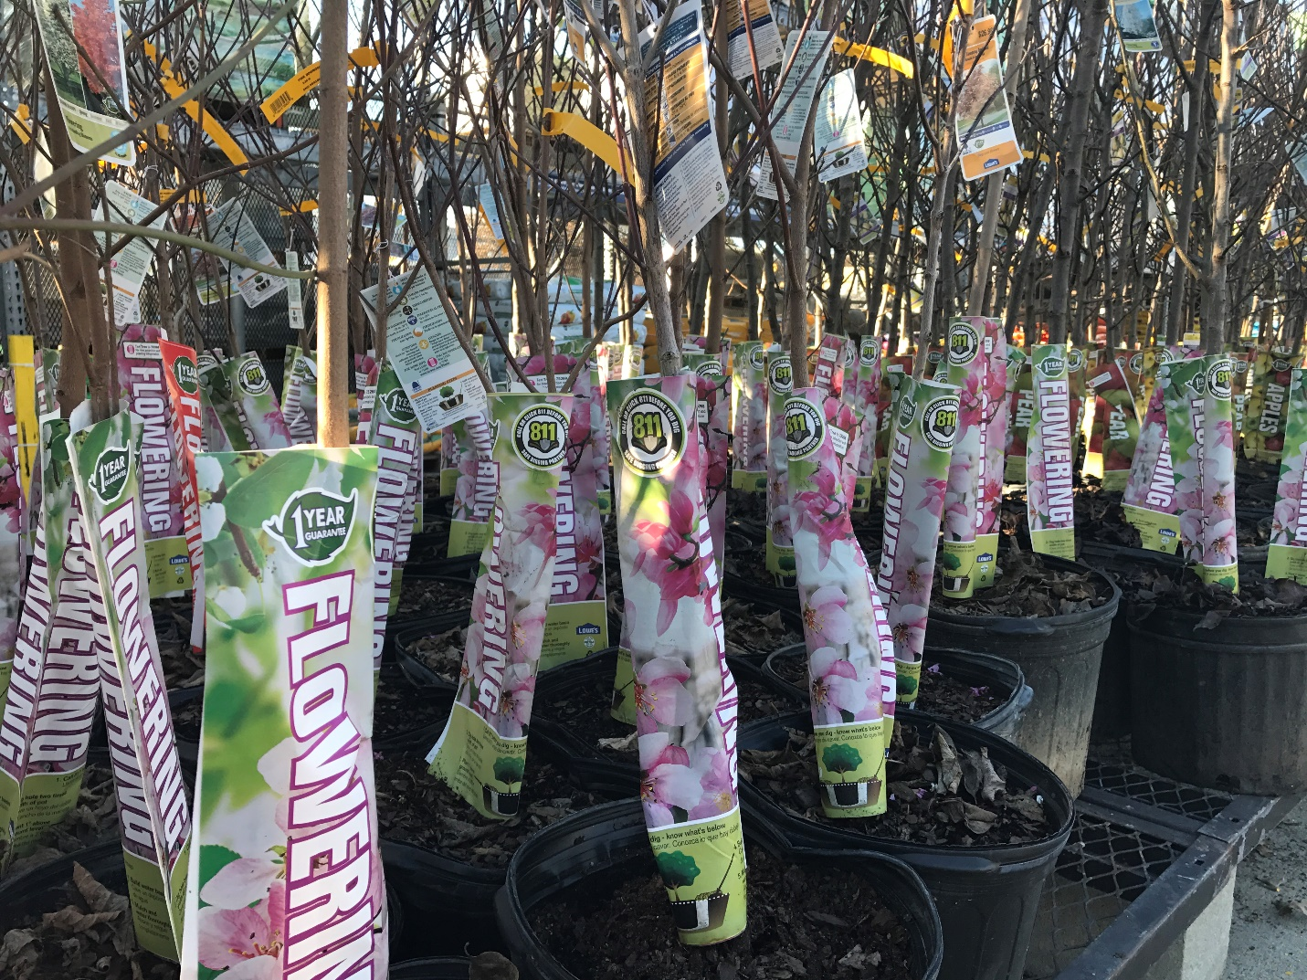
Please contact Ann Rushing, NC811 - Education Manager with any questions and use of the toolkit at 336-944-5518 or annrushing@nc811.org.

Official Logo

The following are the approved logos for the Lowe’s initiative. Many stakeholders are considering adding Lowe’s under their Safe Digging Partner areas on their websites as well as in industry link sections. The main objective is to reciprocate the partnership by sharing.

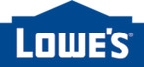

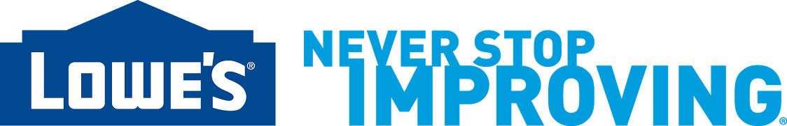

Please link the Lowe’s logo to: https://www.lowes.com/c/Plants-planters-Outdoors.

Social Media Messages

Social media has become an integral tool in how society sends and receives information, communicates with family members and colleagues and learns about new products and services. Facebook and Twitter become two of the best and most cost-effective ways for stakeholders to communicate their various audiences about the Lowe’s partnership.
To assist stakeholders who have created Facebook and Twitter accounts for their organizations, provided are a series of recommended messages for your use.
Hashtag - #811Lowes
Please review the list of recommended messages below and use them verbatim or modify them as needed. You’ll notice that we’ve added the #811Lowes hashtag to the end of these messages. This will allow any stakeholder to visit http://searchtwitter.com or Facebook search and type #811Lowes into the search field to see what everyone else is saying about the 811/Lowe’s partnership throughout the country. Feel free to create social media campaigns around the hashtag #811Lowes.
Facebook & Twitter
We have exciting news! 811 and Lowe’s have collaborated to share the Call Before You Dig message on their tree wraps. Visit any Lowe’s store nationwide. #811Lowes
Want to increase your property values and lower your energy costs? Planting a tree does both. Visit a Lowe’s Garden Center near you and be sure to Call 811 before you dig. #811Lowes
Three trees placed strategically around a single-family home can cut summer air conditioning needs by up to 50 percent. Visit a Lowe’s Garden Center near you and be sure to Call 811 before you dig. #811Lowes
An apple tree can yield up to 15-20 bushels of fruit per year and can be planted on the tiniest urban lot. Visit a Lowe’s Garden Center near you and be sure to Call 811 before you dig. #811Lowes
Trees increase property values! The beauty of a well-planted property and its surrounding street and neighborhood can raise property values by as much as 15 percent. Visit a Lowe’s Garden Center near you and be sure to Call 811 before you dig. #811Lowes
Friday, April 28 is Arbor Day. NC 811 encourages everyone to plant a tree this year. Visit a Lowe’s Garden Center near you and be sure to Call 811 before you dig. #811Lowes
Saturday, April 22 is Earth Day. NC 811 encourages everyone to plant a tree this year. Visit a Lowe’s Garden Center near you and be sure to Call 811 before you dig. #811Lowes
Monday, March 20 is the first day of spring. Early spring, just as the ground thaws, is the best time plant a tree. Visit a Lowe’s Garden Center near you and be sure to Call 811 before you dig. #811Lowes
April is National Safe Digging Month. Call or Click 811 before you do any spring-time planting. If you plan on planting some trees, visit a Lowe’s Garden Center near you. #811Lowes

Infographics

Approved infographics are included for use in any of your marketing efforts. Approved for use are infographics at your discretion in marketing and advertising material.

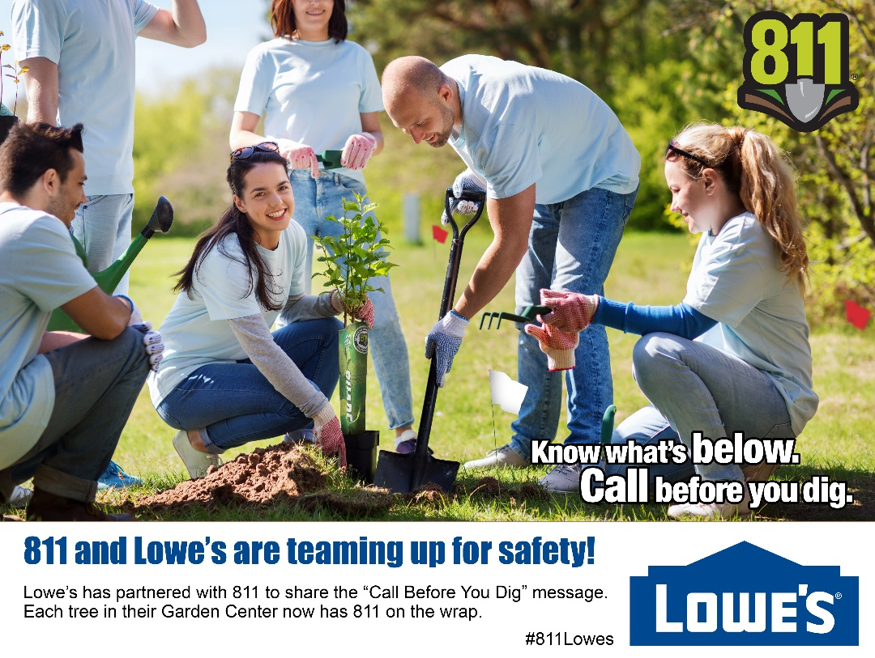

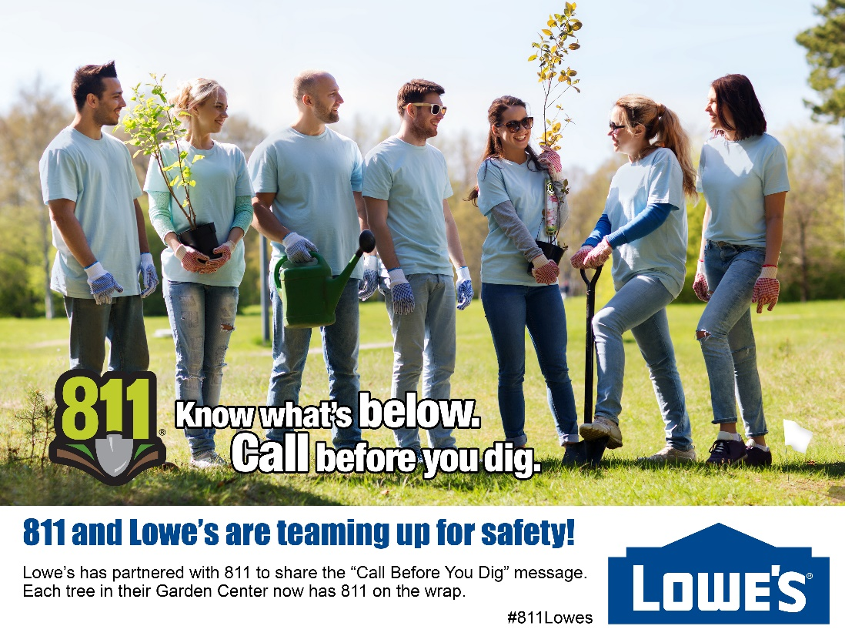

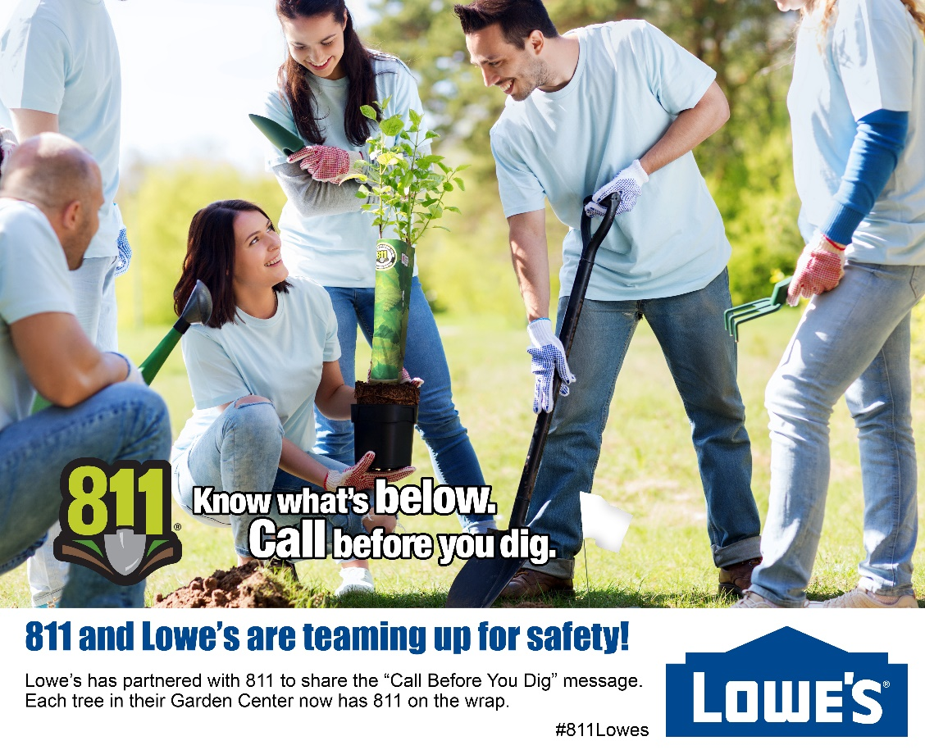

Generic 811/Lowes News Release

[Insert Company Logo]

Media Contact:
[Name]
[Phone Number]
[Email Address]

FOR IMMEDIATE RELEASE

811 and Lowe’s Work to Share Message of Calling before You Dig

CITY, STATE (DATE) – [State]811 is working with home improvement retailer Lowe’s to share an important message – call before you dig. By placing an 811 safe digging partner sticker and “Call 811 before you dig” message on the planting instructions of tree wraps, customers are reminded of the importance of locating underground utilities before beginning a project.

[Stakeholder Name], Executive Director of [One Call Center Name] stated, “What’s great about this program is the ability to educate so many people nationwide about the message of safety to everyone who digs, whether it be a professional or a weekend warrior doing their own DIY project.”

An underground utility line is damaged once every six minutes because someone decided to dig without knowing the approximate location of underground utilities. Digging without calling 811 can result in damage to gas, electric, communications, water and sewer lines, which can lead to service disruptions, serious injuries and costly repairs.

In 2017 alone, over 1.5 million tree wraps in Lowe’s garden centers will share 811 information.

“Everyone who works in the 811 industry nationwide values the impact this messaging brings to protect underground facilities,” added [Stakeholder Name].

Should you visit Lowe’s to purchase a tree, share a photo by using the hashtag #811Lowes. Thanks for helping us come together at the roots to educate about the safety of planting a tree.

About [Stakeholder Name]
[Boiler Plate Information]
More information about the services of [Stakeholder] is available at [Stakeholder Website]

###

