811/Lowe’s Partnership Toolkit

Overview

2016—North Carolina 811 attended a Green Day event with Lowe’s to promote an “811” partnership from a national perspective. A presentation was given and the Merchandising Director of the Live Nursery agreed to add a “811” logo to tree wraps along with instructions to “Call 811 Before You Dig.” The logo was discussed with the One Calls of America subcommittee Mark-it-Madness and the Call or Click Safe Digging Partner logo was approved for use. The approved tree wraps will be placed on trees starting in 2017.
2017—Tree wraps began arriving into stores across the nation in March, 2017 with the “811” Safe Digging Partner logo. Lowe’s has approved a press release, Twitter and Facebook messaging, logos and info graphics for use.
2018- Tree wrap program was approved once again across the nation.
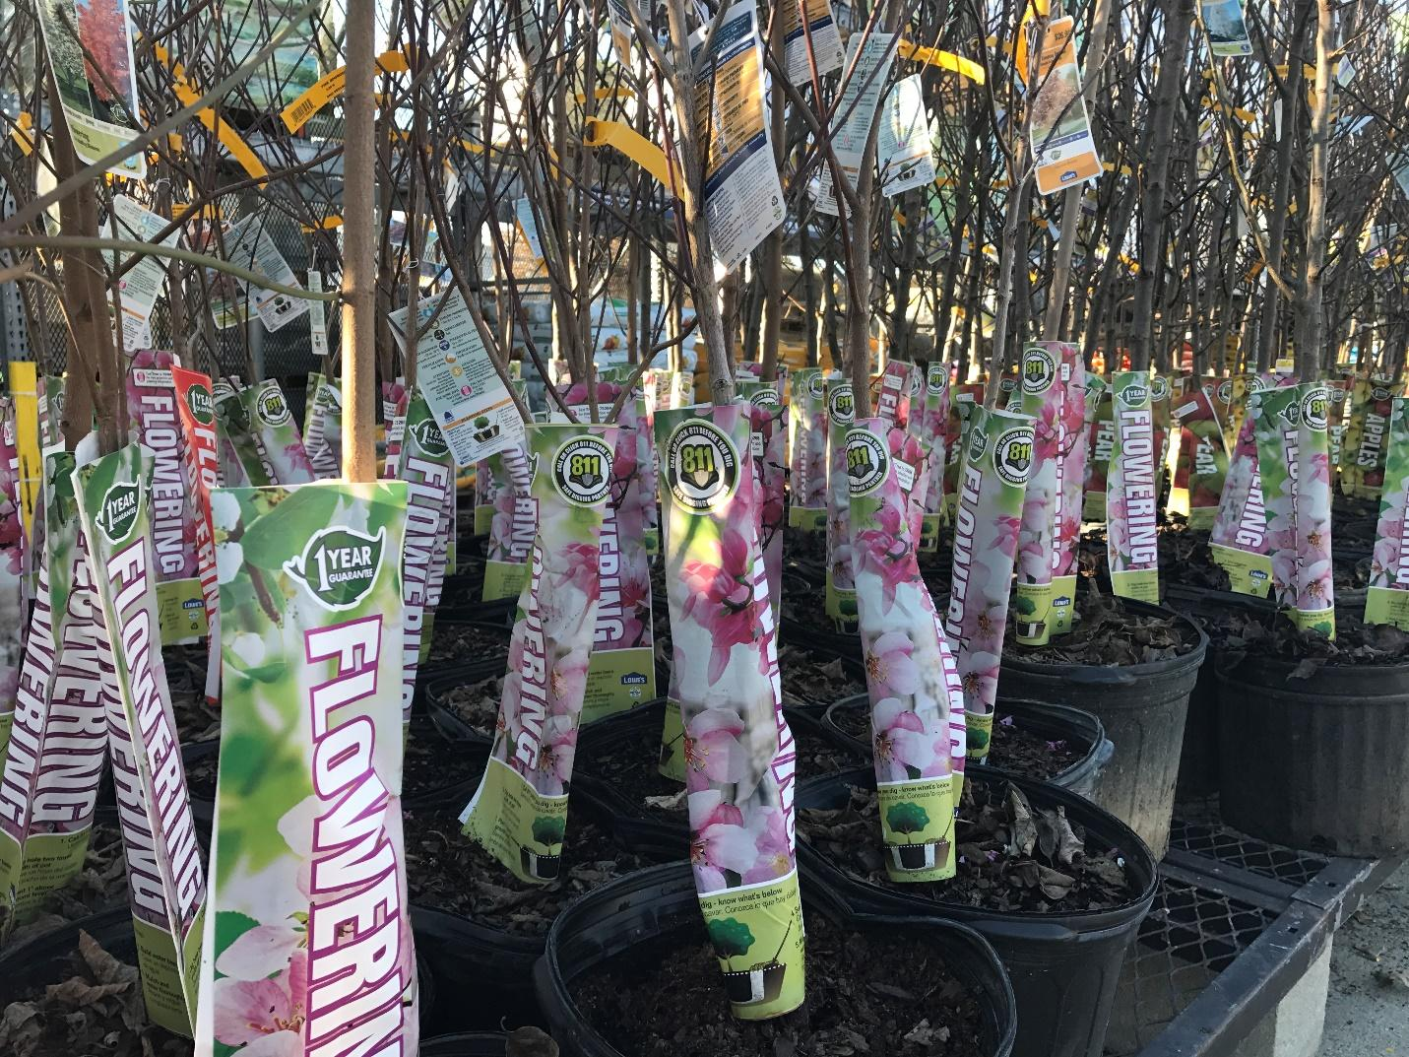
Please contact Ann Rushing, NC811 - Education Manager with any questions and use of the toolkit.
336-944-5518 or annrushing@nc811.org

