811 Hot AIR BALLOON EVENT NEWS RELEASE

[Insert Company Logo]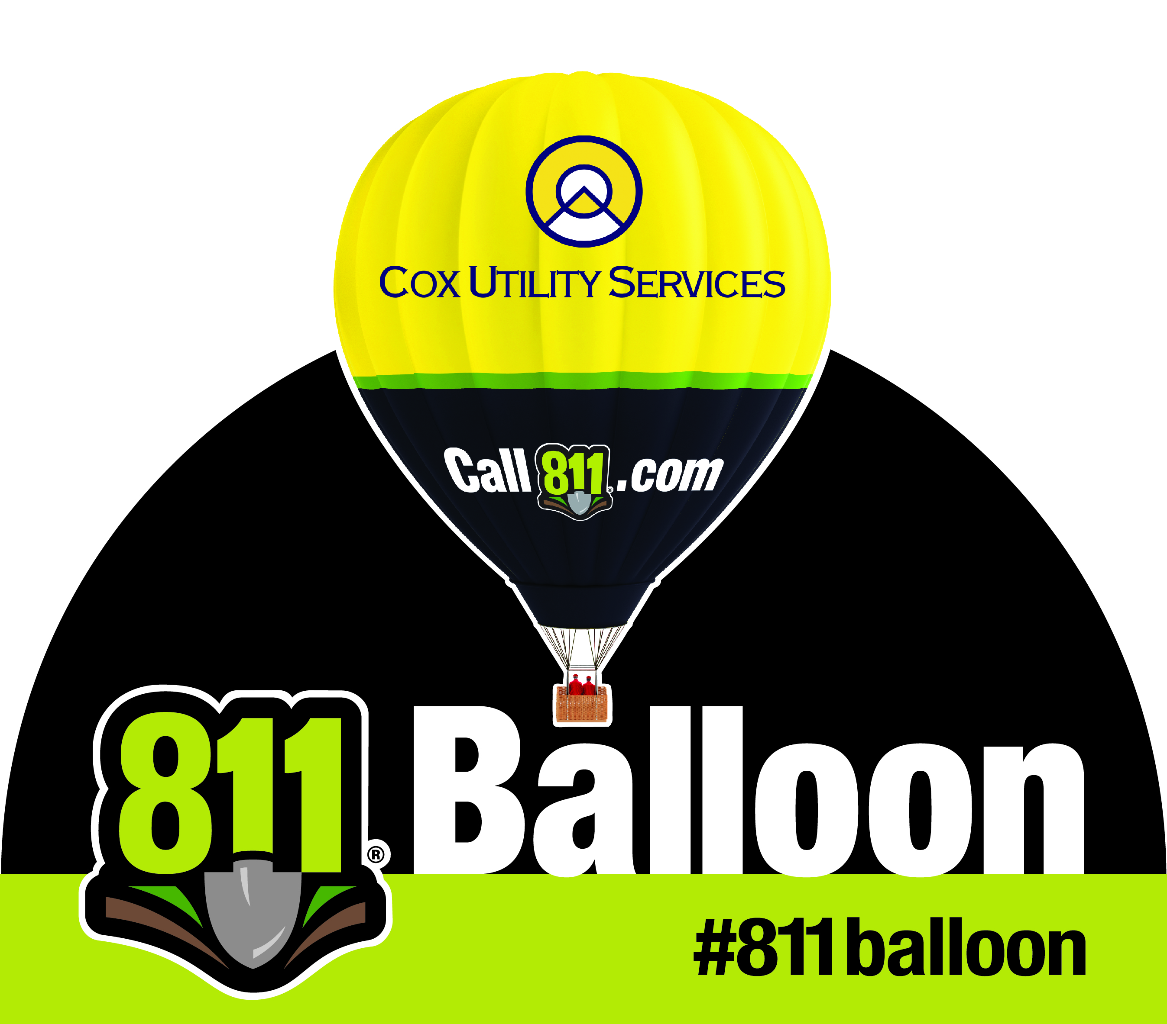
Media Contact:
[NAME]
[PHONE NUMBER]
[EMAIL ADDRESS]

[Insert STAKEHOLDER] BRINGS the 811 hot air balloon to [EVENT]

[Insert Stakeholder Name] hosts the 811 Hot Air Balloon to encourage state residents to always call 811 a few days before digging

CITY, STATE, (DATE) – This digging season, safety is in the air. [INSERT STAKEHOLDER NAME] is reminding STATE residents to always call 811 [INSERT NOTIFICATION PERIOD] before ever breaking ground with a sight you can’t miss – a gigantic hot air balloon featuring the national call before you dig number, 811.

[INSERT STAKEHOLDER NAME] and the 811 Hot Air Balloon will be at [EVENT] on [DATE] at [TIME] offering [members of the public a chance to climb in the basket of the balloon – OR – members of the public a chance to take a tethered ride in the balloon] and information about the importance of calling 811 before digging.

When calling 811, homeowners and contractors are connected to [INSERT ONE CALL CENTER NAME], the local one call center, which notifies the appropriate utility companies of their intent to dig. Professional locators are then sent to the requested digging site to mark the approximate locations of underground lines with flags, paint or both. Every six minutes an underground utility line is damaged because someone decided to dig without first calling 811.

Striking a single line can cause injury, repair costs, fines and inconvenient outages. Every digging project, no matter how large or small, warrants a call to 811. Installing a mailbox, building a deck and planting a tree or garden are all examples of digging projects that should only begin a few days after a call to 811.

“During this time of year when we know homeowners are doing DIY home improvement projects involving digging, we wanted to bring a larger-than-life reminder of why calling 811 before breaking ground is critical – and that’s why we’re hosting the 811 Hot Air Balloon,” said XXX, XXX [Insert stakeholder representative’s name and title]. “By calling 811 to have the underground utility lines in their area marked, homeowners and professionals are making an important decision that can help keep them and their communities safe and connected.”

The depth of utility lines can vary for a number of reasons, such as erosion, previous digging projects and uneven surfaces. Utility lines need to be properly marked because even when digging only a few inches, the risk of striking an underground utility line still exists.
[Insert stakeholder] encourages area residents to visit [Insert stakeholder URL] or www.call811.com for more information about digging safely.

# # #

811 HOT AIR BALLOON MEDIA advisory

[Insert Company Logo]
Media Contact:
[NAME]
[PHONE NUMBER]
[EMAIL ADDRESS]

[Stakeholder Name] to Host 811 Hot Air Balloon at

[Event]

[STAKEHOLDER NAME] reminds [STATE] residents to always call 811 before digging

WHAT: [Stakeholder Name] will host the 811 Hot Air Balloon on [Day], [Date] as a larger-than-life reminder of why it’s important to always call 811 before beginning projects like planting trees or installing a fence that require diggign. [One to two sentence description of what will be taking place].

WHY: Every six minutes an underground utility line is damaged because someone decided to dig without first calling 811. [Stakeholder Name] will be educating the public about the easy, free 811 process that they need to take at least [waiting period] before beginning common outdoor DIY projects involving digging.

WHEN: [Day of the Week], [Date]
[Event Starting Time] – [Event Ending Time]

WHERE: [Street Address]
[City], [State] [Zip Code]

For more information visit www.Call811.com or [Stakeholder URL].

# # #

